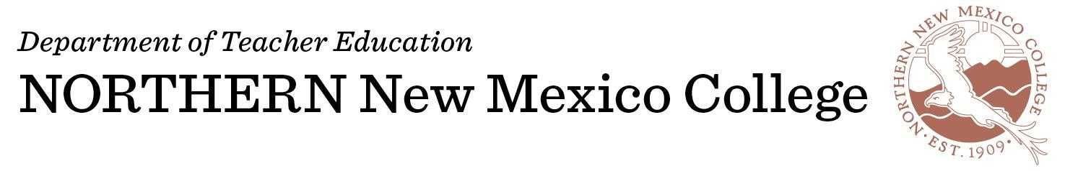
TEACHER RESIDENCY STUDENT APPLICATION FORM

Prerequisite to Teacher Residency Student Application:
Admission and acceptance to Northern New Mexico College (NNMC) and Department of Teacher Education (DTE) must be completed with all required DTE documents on file before applying to the Teacher Residency Program. Required DTE documents that must be on file are: 1) Letter of Intent, 2) Assurance Form, 3) Philosophy Statement, 4) Entrance Interview, 5) Unofficial College/University Transcripts, 6) Two Letters of Recommendation-one of suitability for the profession and a character reference.

Date: FALL Semester: SP Semester: | Banner ID#: 0000

Please select Only One of the following program areas:

Bachelor of Arts: ____Elementary K-8 ____Early Childhood Education

Alternative Licensure: ____Elementary K-8 ____Secondary 7-12 ____Special Education K-12

Endorsement

______Bilingual Education ______TESOL ______Math ______Science

Name: Last | First | MI

Address: P.O. Box/Street | City | State | Zip

Primary Email:
Secondary Email:

Phone: Home/Message | Work: | Cell:

How many hours have you completed towards your licensure program?
When do you anticipate completing your licensure program?
What is the name of the school district you would anticipate requesting a placement?
What is the name of the school site you would anticipate requesting a placement?
What is the grade level you would anticipate requesting?
What is the subject area you would anticipate requesting (if applicable)?
Are you a transfer student:______Yes ______No
If Yes, name of college/university:

Do you have a current background check:______Yes ______No

What is your Ethnicity:
If Native American, what tribe:

Primary Language Spoken:

Signature: | Date:

………………………………………………………………………………………………………………………
OFFICE USE

Application Reviewed By: Date:

Recommended for Teacher Residency Program:____Yes _____No Date:

Approved:____Yes ____No DTE Chair: Date:

