Northern New Mexico College



Campus Emergency RESPONSE PLAN
Revision Date: October 2023
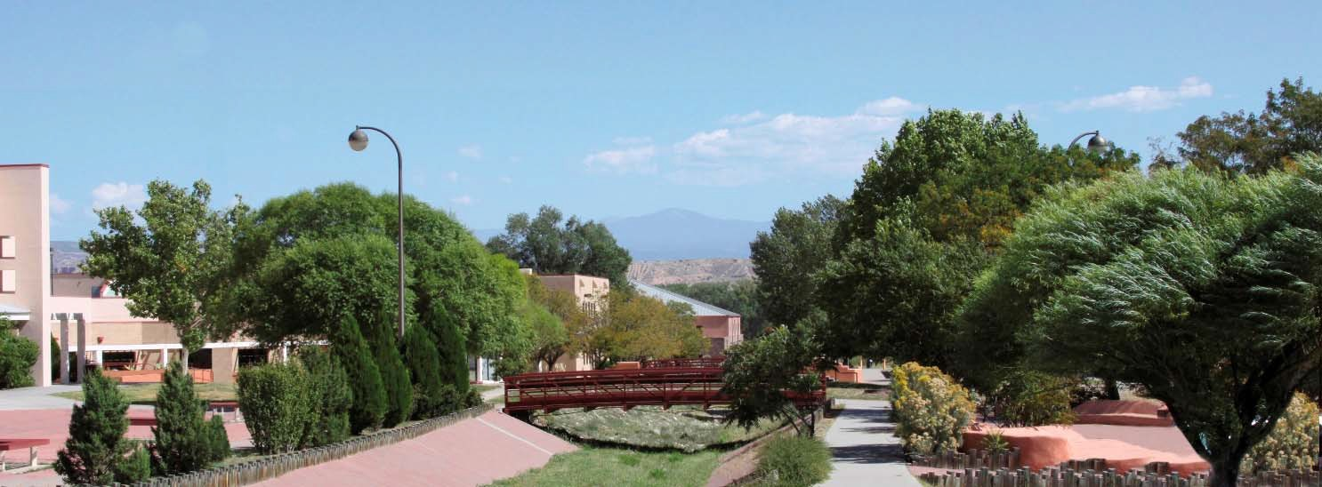
921 Paseo De Onate ▪ Espanola, New Mexico ▪ 87532 ▪ (505)753‐2100 ▪ www.nnmc.edu

Acknowledgements
*********************************************************** We acknowledge the following persons, committees, and offices who have contributed to the development of this Campus Emergency Response Plan.

Hector Balderas., College President
Provost, Vice President for Academic Affairs
VP for Finance and Administration
Chief Information Officer, IT
Associate Vice President for Student Services
Safety and Security Director
Facilities Director
Director Financial Aid
Campus Emergency Response Team Committee IT Department Personnel
Facilities Department Personnel Campus Security Office Personnel

PART ONE – INTRODUCTION

Purpose and Scope of Plan

Northern New Mexico College is committed to the safety of students, faculty, staff and visitors on its campus. This Campus Emergency Response Plan (CERP) is the official plan of the college and is part of the overall emergency preparedness efforts. The plan will address emergency preparedness and response procedures related to life‐threatening events, emergencies, natural disasters, and specific circumstances that constitute an emergency.

The Northern New Mexico College (NNMC) Campus Emergency Response Plan (CERP) has been created to serve as a blueprint for actions to be instituted by the students, faculty and/or employees of NNMC whenever a real or perceived emergency threatens the college population on campus. For the purpose of this plan, an emergency is defined as a situation or the threat of an impending situation with potential to negatively affect the health, safety and welfare of the campus community and/or the integrity of campus buildings or environment.

This plan provides a uniform approach for managing response to all types and sizes of real, potential or perceived emergency, with full implementation required only for major disasters involving a large portion of the campus community. Following identification of an emergency situation, the Northern New Mexico College President or designee will notify the necessary Campus Emergency Response Team (CERT) members and activate the appropriate level of response in accordance with this plan.

Approval Statement

This Campus Emergency Response Plan for Northern New Mexico College has been reviewed and is hereby approved. This plan is effective immediately and supersedes all other plans.

President Hector Balderas
President | Signature | Date
Vice President for Finance & Administration | Signature | Date
Provost & Vice President for Academic Affairs | Signature | Date
NNMC Safety & Security Director | Signature | Date
NNMC Facilities Director
Add all 6 of the executive team | Signature | Date

RECORD OF DISTRIBUTION AND CHANGES

Northern New Mexico College Campus Emergency Response Plan

This plan will be reviewed and approved annually in August. All updates and revisions to the plan will be tracked and recorded in the following table. This process ensures the most current version of the plan is made available at all times.

Date of Origin |  | Entered by | Action / Summary of Description
March 2, 2016 |  | Jimi Montoya | Administrative Approval
Change # | Date of Change | Entered by | Action / Summary of Description
1 | March 12, 2018 | Jimi Montoya | Reviewed/Revised by Executive Management Campus Emergency Response Team
2 | October , 2023 | Patrice Joleen Trujillo, Health & Safety Officer | Revision of NNMC Campus Emergency Response Plan

EMERGENCY TRAINING SCHEDULE

Northern New Mexico College Campus Emergency Training Schedule

NNMC will conduct frequent and consistent training as indicated below.

Schedule | Type | Responsible
Fall Convocation | Classroom General Training | Provost
Annually in the Fall | Fire Evacuation / Bomb Threat | Director of Facilities
Bi‐Annually in the Spring | Active Shooter | Director of Facilities
Annually in the Summer | Building Coordinator Training | Director of Facilities
Monthly at NEO | NNMC New Employee Orientation | Director of Human Resources

CAMPUS EMERGENCY RESPONSE TEAM (CERT)

PERSON | POSITION | CONTACT INFORMATION
President Hector Balderas | NNMC President | (505)747-‐2140
 | Provost | (505)747‐2225
Theresa Storey | VP Finance and Administration | (505)747-2143
Scott Stokes | Director of IT Services | (505)747-2139
Shawn Madrid | Director of Facilities & Safety | (505)747-5432
Melvin Moquino | Campus Security Officer | (505)747‐2158
 | Director of Financial Aid | (505)747‐5034
Debra Trujillo | IT Web Administrator | (505)747-2259
 | Dean of Students

Emergency Phone Numbers

Police/Fire/Medical Emergencies 911
NNMC President. (505) 747‐2140
NNMC Provost (505) 747‐2225
NNMC Director of College Facilities. (505) 747‐5432
NNMC Campus Security Officer Office (505) 747‐2158
NNMC Dean of Students (505) 747‐2122
NM State Police (505) 753‐2277
Rio Arriba Sheriff Office (505) 753‐3329
Espanola City Police (505) 753‐6002
Espanola Fire Department (505) 753‐0037
Espanola Hospital (505) 753‐7111
Espanola Rape Crisis Center (505) 753‐1656
National Emergency for Toxic Chemical & Oil Spills (800) 424‐8802
New Mexico Poison Center (800) 222‐1222

Emergency Chain of Command Authority

In the event of an emergency, the chain of authority for administrative decision‐making is as follows:

- NNMC President or Designee
- Vice President of Administration & Finance
- Provost
- Dean of Students
- Campus Security Officer/Security and Safety Director
- Facilities Director
- Next highest chain of authority

Administrative decisions relating to emergency situations ‐ such as the decision to cancel classes, to send employees home, or to close the college ‐ are made by the top‐ranking available person in this administrative chain of command authority.

NNMC Campus Evacuation Plan
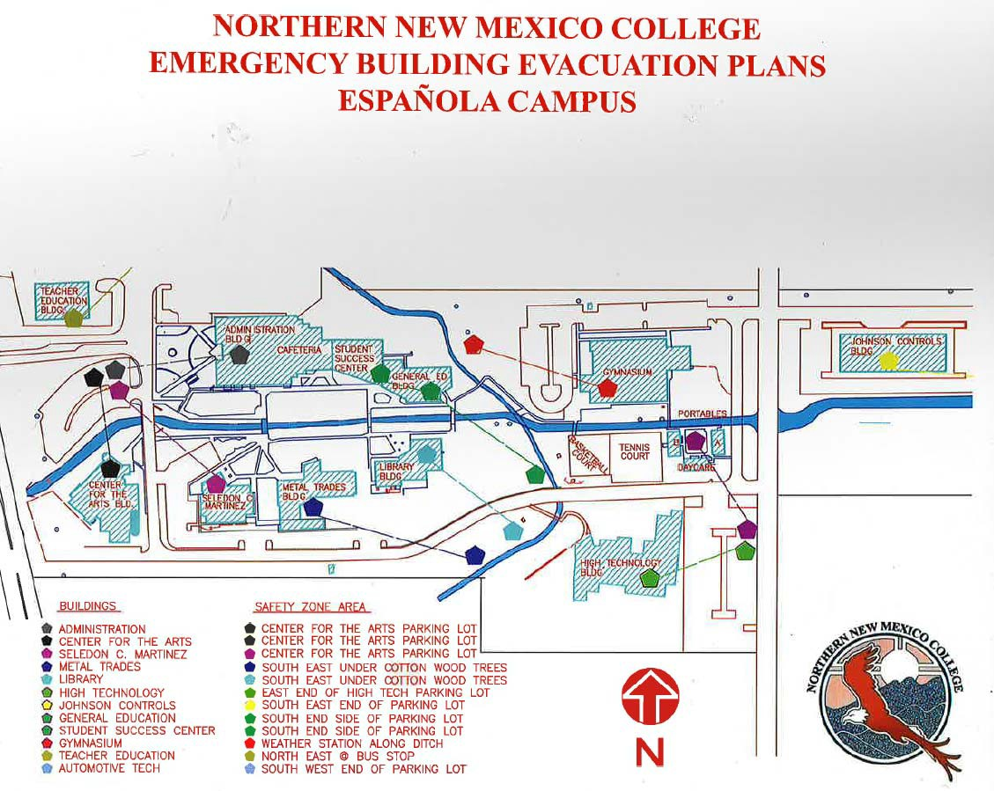

NOTE: This is missing SERPA

Insert Building Evacuation Plans (Facilities)

(Routes to leave a specific building)

Building Coordinators’ Responsibilities/CERT

Utilized as a team, these individuals shall receive training in the area of Community Emergency Response consistent with the guideline of the Federal Emergency Management Agency.
Director of Safety and Security - Admin
Director of Facilities – Admin
Assistant Director of Facilities - Admin
Safety Officer - Admin
President - Admin
Vice President for Finance and Administration or Vice President for Academic Affairs - Admin

Training includes Fire Safety, Light Search and Rescue, Disaster Triage, and Disaster Recovery. These skills will be used during emergency and non‐emergency circumstances. Additional responsibilities include:

During Emergency Only.
Communicate with NNMC Campus Emergency Response Team if activated during an emergency Coordinate evacuation with other employees, ensure the building is cleared/secured/marked prior to leaving.

Routine Issues.
Maintain current Emergency Operations Plan. Know area evacuation routes.
Ensure postings of evacuation routes.
Ensure each area/building has emergency guidelines posted. Informs instructors to make classes aware of guidelines.
Attend training as offered (along with back‐up coordinator). Know location/operations of fire extinguishers.
Coordinate evacuations as needed.

NNMC – GENERAL EMERGENCY PROCEDURES

The following are the ‘high‐level’ Campus Emergency Response Plan (CERP) procedures that Northern New Mexico College (NNMC) must follow if a threat or perceived threat of danger is received by the campus students, faculty or staff. Communication is paramount when responding to an emergency. Therefore, each of the responsible members of this Campus Emergency Response Team (CERT) must have specific and detailed instruction (Appendix A) on how to carry out their specific duties as members of the team. Furthermore, all activity must be recorded and archived. Here are the guidelines:
  - Notification of an emergency on campus is received.
  - Communication is immediately delivered to the NNMC Campus Security Office (CSO) at (505)747‐2158.
  - CSO validates/confirms the emergency to the best of their ability.
  - CSO determines if there is ‘imminent threat’ to the lives of the campus community
  - If determination is ‘Yes’:
    - CSO contact the Information Technology CERT members and instructs them to immediately send out the appropriate broadcast text message, email and phone call communicating the emergency to the campus community.
    - The IT member immediately logs on to the emergency response software which are detailed in Appendix A. and sends out the message. This communication must be complete within 10 minutes of the initial notification.
    - The CSO notifies other CERT members to initiate their individual CERP procedures. i.e., On the website, phone system, call the Sheriff’s Office or City Police, etc.
  - If determination is No:
    - The CSO contacts IT emergency staff to broadcast a message to all members of the CERT.
    - Members are instructed to convene at the primary location. If this location is unavailable, the alternate location is specified.
    - The CERT shall:
      - Request others from the campus community to join if appropriate.
      - Discusses and determine the extent of the emergency.
      - Determine what action is necessary and appropriate.
      - Determine if a message should be sent.
      - If ‘YES’, send out appropriate predetermined message with modifications.
      - Re‐Convene at the end‐of‐day to determine if response is ongoing or can be concluded.
    - A designated member of the CERT must record all CERT activity.
    - When emergency is declared over, a signed ‘NNMC CERT Document of Activities’ must be signed and dated by the highest official on the team.
    - The document shall be archived for future reference.

ACTIVE SHOOTER

This Crisis Situation Response is to be utilized for situations where an actual crisis situation has occurred. An appropriate response should be implemented for any situation involving the following scenarios:
Shots being fired on or immediately adjacent to the campus. Report of weapon(s) on campus.
A stabbing on campus.
An explosion on or near campus.
A hostage situation or an armed barricaded subject on or immediately adjacent to the campus. A natural disaster, hazardous materials incidents, or threats involving weapons of mass destruction which would indicate immediate danger to those on campus.

Immediate Actions for Active Shooter: Concept is to RUN – HIDE – FIGHT!

RUN – Try your best to evaluate the situation and run away from the threat if it is safe to do so.
- Consider risks before leaving but do not stay if others will not go
- Avoid escalators and elevators
- Remember, the shooter is looking for 'targets of opportunity' and generally will need to be stopped by an outside force.
- Do not evacuate rooms or buildings unless it is absolutely clear and safe to do so.
- Rescue attempts should only be tried if they can be accomplished without endangering lives. When in doubt, ‘Shelter‐in‐Place’ and wait for instructions from emergency personnel.

HIDE – If running is not an option, hide in a safe place as soon as possible and maybe run when it is safe to do so. Hide behind thick walls, desks or anything that help prevent injury.
- Lock and barricade doors with heavy furniture to prevent shooter from entering
- Lights Out ‐ Block windows ‐ Silence cell phones ‐ Close blinds ‐ Turn off radios Keep calm, quiet, and out of sight
- To protect yourself from gunfire, take cover behind thick desks, along concrete walls, or against filing cabinets
- Find a room that locks, but only if it is safe to move around
- Use strategy to silently communicate with first responders if it is save to do so
- Hide in an area that is out of view from the room entrance door or hallway
- Remain in place until all clear is given by identifiable law enforcement

FIGHT – ‘TAKE OUT’ Use your best judgement to FIGHT when you are unable to RUN or HIDE.
- Work together as a team TAKE THE PURPRETRATOR OUT with aggressive force.
- Find objects such as fire extinguisher, chairs, etc that may be used as weapons.
- Do whatever is necessary to overcome him/her.
- Realize this is a Life or Death situation
- You must incapacitate him/her
- Restrain him/her with any material you have available to you
- Kick weapon away from area. Do not pick it up.

Reporting and Emergency: Call 911 or notify the Campus Security by calling (505) 747‐2158 from cell phones. Do not hang up on the dispatcher until told to do so. Provide the following information:

- Clearly state there has been a shooting or someone has been shot. The exact location of the suspect(s) including building, type of building, room/office number, front or side window, roof, office, classroom, etc.
- Number of shots fired by the suspect(s), if the suspect(s) is still shooting, and type of weapon(s) (rifle, shotgun, handgun, etc.) or explosive device(s) if known.
- Description of suspect(s), their clothing, color of hair , height,
- Describe the vehicle used, and direction of travel.
- Condition and number of hostages, and number of known injured or killed.
- Any demands or information supplied by suspect(s).

College staff members should refrain from attempting to negotiate with the violator(s) as numerous hostage situations have ended in tragedy when well‐intended, and untrained civilians attempted to help with negotiations.

PREVENTION:

Ask for help ‐ if you, or if you know someone who is feeling desperate, we want to help. Report concerns about your friends to any campus employee.

- Unusually angry or argumentative?
- Noticeable changes in behavior?
- Blame others for their problems?
- Extreme disorganization?
- Retaliate against perceived injustice?
- Increasing belligerence?
- Fail to take responsibility for their own actions?
- Ominous, specific threats (homicide, suicide, etc)?
- Preoccupation with violent themes?
- Hypersensitivity to criticism?
- Recent acquisition/fascination with weapons?
- Interested in recently publicized violent events?

LOCKDOWN:
A lockdown/shelter‐in‐place situation can be initiated under the following: Someone who has a gun or weapon (Active Shooter)
An out‐of‐control student who is a threat to the safety of other students, faculty, staff or himself/herself
An intruder
Hazardous chemical spill outside the building
Weather related events (severe lightning, high winds, etc.) Down power lines outside a building

STAFF AND FACULTY RESPONSIBILITIES

- Notify the Campus Security Officer by calling (505) 747‐2158. Provide the dispatcher with all available information regarding the threat.

- If an assessment of the situation indicates that it is safer to remain in the classroom than to leave it, lock or barricade classroom doors once the hallways near their room are clear of students. Do not open doors unless instructed to do so by a staff or authorized personnel that are recognized by sight or voice. Emergency Responders may enter the room using a master key or by providing positive identification.

- If an instructor observes imminent danger near room immediately secure their room and notify the Campus Security Officer of the danger via telephone, radio system or runner.

- Brief students that the College has been placed on a heightened security status as a response to an apparent crisis situation. Ask students to remain quiet until more can be learned about the situation.

- Calmly and quietly review emergency evacuation procedures with students to prepare them for possible evacuation.

- Until the situation has been assessed, recommend that students remain in classroom (Shelter‐in‐Place) unless authorization is received from appropriate authority.

In the event that you are outside when this event occurs take the following actions:

- Notify the Campus Security Officer by calling (505) 747‐2158. Provide the dispatcher with all available information regarding the threat of an explosion.

- Proceed to assigned class or an indoor secure area unless otherwise instructed by the building administrator/department head. If the assigned class is not accessible or is unsafe proceed to the nearest classroom.

- Seek shelter in the safest place available if it is unsafe to enter a campus building. If the decision is made to leave the campus, faculty/staff should notify their supervisor or department head, or emergency response personnel of their location and the number and names of students/ employees present. Notification should occur as soon as it is safe to do so.

RETURN TO NORMAL OPERATIONS

Once the danger has passed the College President or a member of the Executive Management may be able to put the College back to normal status. The campus should be returned to normal operations when all of the following three conditions are met:

- There is no indication that an above normal level of danger exists.
- Further measure such as evacuation will not be needed.
- It is possible for the functions of the College or department to continue.

- If the building is evacuated use the campus emergency notification channels to announce that a return to normal operations is being implemented. The return to normal operations will be announced by proper authority going from room to room if students and faculty remained in rooms during the emergency.

- An announcement to inform College faculty, staff and students as to the reason that normal campus operations were interrupted is beneficial to prevent rumors from causing undue alarm within the College.

BOMB THREAT

Bomb threats are usually received by telephone, but may also be received by note, letter or email. All bomb threats should be taken very seriously and handled as though an explosive were in the building. Act quickly, but remain calm and obtain information with the checklist located in Appendix B.

If a bomb threat is received by phone:

- Remain calm. Keep the caller on the line for as long as possible. DO NOT HANG UP, even if the caller does.

- Listen carefully. Be polite and show interest.

- Try to keep the caller talking to learn more information. If possible, write a note to a colleague to call the authorities or, as soon as the caller hangs up, immediately notify them yourself.

- Ask the person making the bomb threat the following questions:

Where is the bomb going to explode? Why did you choose this location? Where is it right now? What damage will it do?
What does it look like? Do you want people hurt?
What will cause it to explode? What is your name?

- If your phone has a display, copy the number and/or letters on the window display.

- Complete the Bomb Threat Checklist in Appendix B immediately. Write down as much detail as you can remember. Try to get exact words.


If a bomb threat is received by handwritten note:
  - Call the Campus Security Officer at (505) 747‐2158
  - Handle note as minimally as possible

If a bomb threat is received by email:
  - Call the Campus Security Officer at (505) 747‐2158
  - Do not delete the message

Signs of a suspicious package:
    - No return address • Strange odor
    - Excessive postage • Strange sounds
    - Stains • Unexpected Delivery

DO NOT:

  - Use two‐way radios or cellular phone; radio signals have the potential to detonate a bomb.
  - Evacuate the building until police arrive and evaluate the threat
  - Activate the fire alarm.
  - Touch or move a suspicious package.

STAFF AND FACULTY RESPONSIBILITIES

- Most bomb threats are received by telephone. When a staff or faculty member receives a bomb threat they should remain calm and try to get as much information as possible from the caller.

- If a staff or faculty member discovers a suspicious package or object immediately report the package to the Campus Security Officer by calling (505) 747‐2158 as appropriate. Under no circumstances should the package be touched, moved, or tampered with by anyone other than trained personnel.

- When a staff or faculty member is first informed of a bomb threat immediately notify their supervisor or department head and the Campus Security Officer by calling (505) 747‐2158 as appropriate. Provide the dispatcher with all available information regarding the bomb threat.

- The decision to evacuate a particular area of building will be made by campus authorities. Keep all students in the classroom while the bomb threat response is being completed. Move away from doors and windows and give Drop, Cover and Hold Command. Instruct students to stay down until subsequent instructions are given.

- If an assessment of the situation indicates that it is safer to remain in the classroom than to leave it, lock or barricade classroom doors once the hallways near the room are clear of students. Do not open doors unless instructed to do so by a staff member or authorized personnel that are recognized by sight or voice. Public safety responders may enter the room using a master key or by providing positive identification.

- If an instructor observes imminent danger near their room immediately secure their room and notify the Campus Security Officer of the danger via telephone or runner.

- Brief students that the College has been placed on a heightened security status as a response to an apparent crisis situation. Advise students to remain quiet until more can be learned about the situation.

- Calmly and quietly review emergency evacuation procedures with students to prepare them for possible evacuation.

- Until the situation has been assessed, recommend that students remain in classroom unless authorization is received from appropriate authority.

In the event you are outside when this event occurs take the following actions:

- Move away from the danger area to a safe location. Notify the Campus Security Officer by calling (505) 747‐2158 as appropriate.

- The President or designee will provide directions relating to cancellation of classes, release of students and other follow‐on actions by the faculty and staff.

- Seek shelter in the safest place available if it is unsafe to enter a campus building.

- Assist individuals with disabilities. Request assistance from Security Officer or City of Espanola Fire Department personnel. If assistance is not available and it becomes necessary to move disabled persons, do so carefully. Ask individual if they need assistance.

Return to Normal Operations

Once the danger has passed the Senior College Administrator or Incident Commander may be able to put the College back to normal status. The campus should be returned to normal operations when all of the following three conditions are met:

- There is no indication that an above normal level of danger exists.
- Further measure such as evacuation will not be needed.
- It is possible for the functions of the College or department to continue.

- Using the campus emergency notification channels to announce that the campus is returning to normal operations.

- An announcement to inform College faculty, staff and students as to the reason that normal campus operations were interrupted is beneficial to prevent rumors from causing undue alarm within the College.

EARTHQUAKE

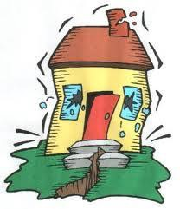
Immediate Actions If Indoors:

Stay calm and try to calm and reassure others.
Duck or drop to the floor. Take COVER under a sturdy desk, table, or other furniture. Hold on to furniture you are under and protect face. Be prepared to move with it until the shaking stops.
If you are not near a desk or table, drop to the floor against the interior wall and protect your head and neck with your arms. Avoid exterior walls, windows, hanging objects, mirrors, tall furniture, large appliances, and cabinets with heavy objects or glass.
INSTRUCT OTHERS TO DUCK, COVER, AND HOLD!
Stay away from glass windows, wall shelves, and heavy equipment.
DO NOT RUN OUTSIDE. DO NOT EVACUATE UNTIL AFTER TREMORS CEASE. Be aware that
Earthquake aftershocks may cause further damage. Once the main tremor has ceased, calmly evacuate building to evacuation assembly area in the Campus Quad. Assist those with physical disability.
GAS LEAKS – If you smell gas, cease all operations. DO NOT SWITCH LIGHTS ON OR OFF. HAZARDOUS MATERIALS RELEASE INCIDENT – Some gasses are odorless and colorless. Do not enter any areas where hazardous materials are store or suspected until uniformed personnel or other trained authorized person has inspected and cleared the areas.

Immediate Actions If Outdoors:

Quickly move at least 300 feet away from buildings, utility poles, and other structures. CAUTION: Always avoid power or utility lines.

After the Earthquake:
- Evacuate building if the earthquake seemed serious enough to cause structural damage by moving quickly to the evacuation point shown on the Emergency Exit Plan posted in each room.
- Expect aftershocks. Move carefully and use extreme caution when moving around damaged buildings because aftershocks can cause further damage.
- Check for injuries, trapped persons and disabled persons in your vicinity.
- Check for fires. If you can, extinguish with a fire extinguisher. If not, leave the area and call the Campus Security Officer at (505) 747‐2158.
- Clean up spilled chemicals or other potentially harmful materials, if safe to do so.
- Do not use electric equipment. Turn electrical switches off and do not light matches.
- Do not touch downed power lines, other exposed wires, or objects touched by downed lines.
- Do not use telephone unless an emergency requires it.
- Check closets and storage shelf areas. Open doors carefully and watch for falling objects.
- Listen for damage reports and evacuation information. Do not spread rumors.
- Do not return to an evacuated building until instructed to do so by emergency personnel.

EVACUATION

Emergency evacuation of a building/buildings or the campus may be required due to situations such as a major fire, an explosion or a major crisis situation. An evacuation plan should be preplanned in order to move away from a threatened building or area toward an evacuation area.
The evacuation protocol shall be used under the following conditions: An explosive device detonates on campus.
A functional explosive device is found on campus.
A hostage situation takes place on campus.
A situation involving a barricaded subject armed with explosives or firearms takes place on campus.
A severe weather crisis occurs which requires removal of personnel to a safe remote location.
A weapon of mass destruction or hazardous materials incident occurs on or near the campus and public safety responders determine that mass evacuation to a remote location is required.
Whenever the facility or grounds are rendered unsafe and evacuation to a remote site is needed.

PRESIDENT / CAMPUS SECURITY OFFICER / KEY PERSONNEL

- Notify the Campus Security Officer by calling (505) 747‐2158, as appropriate. Provide the dispatcher with all available information about the situation that may result in the evacuation of the campus.

- The Campus Security Officer Deputy or the Incident Commander will ensure that the appropriate levels of notifications are made to the College administration and that the appropriate reports are completed detailing the events and actions taken.

- For small scale evacuations the Campus Security Officer Deputy/Incident Commander, Northern New Mexico College President or senior official will make the determination of the need to evacuate a particular area. For large scale evacuations the Northern New Mexico College President or senior official present will make the determination to order an evacuation based on a consultation with the CERT and/or the Campus Security Officer. A campus wide evacuation order will be made by the Northern New Mexico College President or College Senior Official present will make the determination to order an evacuation based on a consultation with the Threat Assessment Team and/or the Campus Security Officer.

- Implement Evacuation Plan.

- As the chief investigative body for the College, the Campus Security Officer will maintain Incident Command on all incidents that could reasonably lead to a criminal investigation. In incidents where the Campus Security Officer will not be the primary investigator agency Incident Command will be transitioned to the agency responsible for such investigation upon their arrival. As a matter of course the City of Espanola Fire Department will have Incident Command on all fires and hazmat incidents.

- DO NOT USE campus radios or cell phones if there is a bomb or bomb threat on campus. If there is NO bomb or bomb threat on campus utilize the Campus radios, telephones or cell phones to maintain communications between faculty, staff and students. NOTE: Cell phones and radios are essential tools to maintain communications.

Accountability Procedures for Emergency Evacuations

- Campus and Building Evacuation Maps are located in Appendix G.

- Building Coordinators are designated by the Campus Emergency Response Team and will conduct head counts once evacuation has been completed. There is at least one Building Coordinator per building or not more than twenty occupants to provide adequate guidance and instruction at the time of an emergency.

- The employees selected as Building Marshals are to be trained in the complete workplace layout and the various primary and alternate escape routes from the workplace.
  - All Building Marshals are to be trained in the evacuation of disabled individuals, and equipment necessary for that evacuation.
  - Awareness of hazardous areas to be avoided during emergencies.
  - Before leaving, the Building Marshals are to check rooms and other enclosed spaces in the workplace for other employees who may be trapped or otherwise unable to evacuate the area, and convey this information to emergency personnel.

- Once each evacuated group of employees have reached their Designated Meeting Site, each Building Marshals:
  - Assembles his/her group in the Designated Meeting Site.
  - Takes head count of his or her group.
  - Assumes role of department contact to answer questions.
  - Instruct personnel to remain in area until further notice.
  - Reports status to CERT or Campus Security Officer Deputy (if activated).

  - Instruct personnel to remain at Designated Meeting Site until further notice.

EMERGENCY EVACUATION KITS. (NNMC Needs to build them)

The College should maintain two Emergency Evacuation Kits. The two Emergency Evacuation Kits should contain the following items:

A copy of the Northern New Mexico College Campus Emergency Response Plan. A set of master keys for all doors and wall lockers.
A set of building plans, including all gas, electrical, cable shut‐offs and water risers. A complete list of all cellular phone numbers for College administration.
Emergency Evacuation Kits should contain information relating to the emergency response equipment and its location.

Considerations for Emergency Evacuation Plan development, include the following items:

Plan alternative evacuation plans for different directions from the campus. Your primary evacuation route may be inaccessible.
Plan alternative student staging/rally areas, based on the above evacuation plans. In some emergencies, gathering students in a large, open area of the campus places them at risk.
Plan "runners" to maintain communication between administration and staging/rally areas, and media staging areas in case electronic communication is interrupted.
Prearrange a media staging area for briefings. Relay information to the College President and/or CERT on a regular basis through electronic means or by runners.

FIRE

The warning for a fire is an alarm and/or smoke and flames. Immediate Actions:
Smell Smoke or Detect a Fire. Prior to opening doors, feel if the door is HOT. Open cautiously. If SMOKE IS HEAVY, stay near the floor where less smoke accumulates.
Pull fire alarm.
Evacuate from the area to the designated assembly area. Assist person with disabilities and children.
Alert classes, students and employees nearby.
Call 911 or your college local emergency number from cell phones and describe location, nature and extent/size of fire. Be sure to mention if there are any known or suspected persons trapped or if hazardous materials are involved.
Call Campus Security Officer at (505) 747‐2158 and provide the dispatcher with all available information regarding the fire.
The Campus Security Officer will ensure that the appropriate levels of notifications are made to the College administration and that the appropriate reports are completed detailing the events and actions taken.


If Fire is minor and controllable:

Direct fire extinguisher(s) toward base of flames. Evacuate immediate area if appropriate.

STAFF AND FACULTY RESPONSIBILITIES

- If the fire is small, you may wish to fight it with an extinguisher. Call Campus Security Officer at (505) 747‐2158 and provide the dispatcher with all available information regarding the fire.

- In case of a fire, employees should activate the nearest fire alarm box and/or make a telephone call to the Campus Security Officer at (505) 747‐2158. This high‐pitched alarm alerts building occupants of the need for evacuation and sends a signal to the Campus Security Officer that there is an alarm condition in the building.

- It may be necessary to activate additional fire alarm boxes, or shout the alarm, if people are still in the building and the alarm has stopped sounding, or if the alarm does not sound. This can be done while exiting.

- Persons discovering a fire, smoky condition, or explosion should pull the fire alarm box. Any pertinent fire or rescue information should be conveyed to the Campus Security Officer.

- Assist individuals with disabilities. Request assistance from law enforcement or City of Espanola Fire Department personnel. If assistance is not available and it becomes necessary to move disabled persons, do so carefully. Ask the individual if they need help then render assistance as directed.

- To report emergencies, call the Campus Security Officer at (505) 747‐2158. State you name, your location, and the nature of the call. Speak slowly and clearly. Wait for the dispatcher to hang up first. On occasion the dispatcher may need additional information or may provide you with additional instructions.

- Make certain every student has left the classroom. In the event that a person has been injured and you are not able to evacuate someone notify the Campus Security Officer personnel, a Building Marshal, or other emergency response personnel that someone is inside the room.

- Close the doors and windows and accompany your class to the designated assembly area.

- Upon reaching your assigned assembly area, immediately take attendance.

- Render first aid as necessary.

- Follow instructions from proper authority relating to continued operations.

Evacuation Procedures for Building Occupants

- When the fire alarm sounds, all personnel should ensure that nearby personnel are aware of the emergency, quickly shutdown operating equipment (e.g., compressed gas cylinders), close doors and exit the building using stairwells.

- All occupants should proceed to their Designated Assembly Area and await further instructions from their Building Marshals.

- All personnel should know where primary and alternate exits are located, and be familiar with the various evacuation routes available.

- Building occupants must NOT use elevators as an escape route in the event of a fire.

Notes and Precautions:
Small fires can be extinguished only if you are trained to use a fire extinguisher. However, an immediate readiness to evacuate is essential. All fires, even those that have been extinguished, must be reported to the Campus Security Officer immediately at (505) 747‐2158. Never enter a room that is smoke filled. Never enter a room if the door is warm to touch.

Return to Normal Operations

Once the danger has passed the Senior College Administrator or Incident Commander may be able to put the College back to normal status. The campus should be returned to normal operations when all of the following three conditions are met:

- There is no indication that an above normal level of danger exists.
- Further measure such as evacuation will not be needed.
- It is possible for the functions of the College or department to continue.

- If the building is evacuated use the campus emergency notification channels to announce that a return to normal operations is being implemented. The return to normal operations will be announced by proper authority going from room to room if students and faculty remained in rooms during the emergency.

- An announcement to inform College faculty, staff and students as to the reason that normal campus operations were interrupted is beneficial to prevent rumors from causing undue alarm within the College.

Flooding / Water Damage

There may be areas on the Northern New Mexico College campus subject to or affected by floods. Except in the case of flash flooding, the onset of most floods is a relatively slow process with a buildup of several days. Closure of highways can result in isolating areas of the community. Students may be unable to return home or may have to be evacuated to an alternate location.

Northern New Mexico College officials may be alerted to danger and be ordered to evacuate by fire and/or law enforcement or local emergency officials.

Should a flooding situation occur, an orderly evacuation of the area should be initiated, call the Campus Security Officer at (505) 747‐2158. Security Officer’s personnel will notify the appropriate college personnel and dispatch personnel to the area.

Provide the dispatcher with all available information regarding the flooding threat.

Monitor weather conditions in an affected area by radio/TV broadcasts, internet, or weather alert radio.

Evacuate students to an alternate location immediately in accordance with established College policy. If the situation does not permit evacuation, keep students on campus or other safe location and make the following provisions:

- Provide care for students, faculty and staff who cannot leave the campus due to flooded streets etc.

If necessary, arrange for the evacuation of staff and students to a safe alternate location.

Shut off water at mains so contaminated water will not back up into the campus supply.

Be prepared to open designated shelter sites for use.

Check emergency response supplies if the College is designated as an evacuation shelter.

Prepare for contaminated food, water, broken gas lines, and wet electrical equipment.

If classes are dismissed, resume classes only after determination of building safety, and/or in other designated buildings after the flood.

WATER DAMAGE

Serious water damage can occur from a number of sources: broken pipes, clogged drains, broken skylight or windows, or construction oversights.

Request for repairs of leaky pipes and broken faucets are not a flood situation. They are to be reported by sending a work request form to Facilities Maintenance for notification of needed repair.

If a serious water leak occurs:

- Call the Campus Security Officer at (505) 747‐2158. Advise the dispatcher of the exact location and severity of the leak. Indicate whether any valuables are involved or are in imminent danger.
- Notify your supervisor of the extent and the location of the leak, use extreme caution. If there is any possible danger, evacuate the area.
- If you know the source of the water and are confident of your ability to stop it (i.e., unclog the drain or turn off the water), do so cautiously.
- Be prepared to assist as directed in protecting college property and valuables that are in jeopardy. Take only essential steps to avoid or reduce immediate water damage:

Evacuation

Individuals in the hazardous area should be notified/warned and directed to leave the affected area. Do not enter an area that has been flooded until told to do so by emergency personnel. Employees are not to leave the campus until authorized to do so by an authorized administrator or Security Officer’s personnel.

STAFF AND FACULTY RESPONSIBILITIES

  - Any flooding should be reported immediately to Campus Security Officer at (505) 747‐2158.

  - When reporting, be specific about the nature of the exact location. Campus Security Officer will contact the necessary specialized authorities and medical personnel.

  - The key person on site should evacuate the affected area at once and close it off to access until the arrival of Campus Security Officer or City of Espanola Fire Department.

  - If possible have someone remain in vicinity, away from danger, to assist emergency responders in locating the flood.

  - If an emergency exists, activate the building alarm. You must report the emergency by phone.

  - When the evacuation alarm is sounded, walk to the nearest identified exit and ask others to do the same.

  - Assist the Building Monitors in evacuating students to an alternate location immediately in accordance with established College procedures. If the situation does not permit evacuation, keep students on campus or other safe location and make the following provisions.

  - Assist individuals with disabilities. Request assistance from law enforcement or City of Espanola Fire Department personnel. If assistance is not available and it becomes necessary to move disabled persons, do so carefully. Ask the individual if they need help then render assistance as directed.

Return to Normal Operations

Once the danger has passed the Senior College Administrator, or Incident Commander may be able to put the College back to normal status. The campus should be returned to normal operations when all of the following three conditions are met:

- There is no indication that an above normal level of danger exists.
- Further measure such as evacuation will not be needed.
- It is possible for the functions of the College or department to continue.

  - If the building is evacuated use the campus emergency notification channels to announce to announce that a return to normal operations is being implemented. The return to normal operations will be announced by proper authority going from room to room if students and faculty remained in rooms during the emergency.

HAZARDOUS MATERIAL RELEASE

Hazardous materials incidents are possible in numerous campus locations. Also, vehicles carrying hazardous materials on or near campus facilities and businesses operating near our facilities can generate hazardous materials incidents that may affect campus operations.

Immediate Actions:


Safeguard lives and isolate materials if safe to do so.
Notify 911 or call Campus Security Officer at (505) 747‐2158 from cell phones. Minimize property damage.

Determine need to EVACUATE building:

Alert others in building – activate alarm.
Evacuate immediately. Assist persons with disabilities or injuries. Close doors leading into the building to isolate release.
Move and stay unwind, up slope, upstream, at least 300 feet free from building (to evacuation staging areas if safe).
Keep streets and walkways clear for emergency equipment.
Notify 911 or call Campus Security Officer at (505) 747‐2158 from cell phones.

If evacuation of the building/area is required, do the following:

Always move crosswind to avoid fumes. Never move down wind. Follow the directions of the Building Marshals.
Maintain control of students. Render first aid as necessary. Take roll.
After the area has been evacuated, do not return until the City of Espanola Fire Department declares the area safe.

Advise emergency services with:

Exact location of spill, including room number if inside a building. Name of spilled material
Quantity
Appearance – solid, liquid, odor, color, etc.
Injuries or physical effects to those who have been exposed. Whether any victims are trapped within the isolated area.
Area of contamination.
Your name, department, and the phone extension you are calling from.

If hazardous material is on a person remove any excess material and check follow immediate treatment as appropriate:

Hazardous materials in eye: brush away and dry materials, then hold the eye open and flush with water at least 15 minutes.

Hazardous material on skin: remove contaminated clothing, brush away and dry materials and flush area with water in a safety shower for at least 15 minutes.

Seek medical attention immediately! Send Materials Safety Data Sheets (MSDS) in Appendix C with the injured!

Do not return to the evacuated area until the area is declared safe by trained authorized personnel.

STAFF AND FACULTY RESPONSIBILITIES

  - If in your work area there is hazardous material you are not familiar with or may cause harm to yourself or others, or, if there is immediate danger to life, call the Campus Security Officer at (505) 747‐ 2158, as appropriate. The Campus Security Officer or the Office of Administrative Services will immediately notify NNMC Environmental Health & Safety at (505)747‐2158. Keep all students/employees away from the site.

  - For any hazardous material spill, the Campus Security Officer or the Administrative Office will notify Environmental Health & Safety.

  - If evacuation of the building/area is required, do the following:

Always move crosswind to avoid fumes. Never move down wind. Follow the directions of the Building Marshals.
Maintain control of students. Render first aid as necessary. Take roll.
After the area has been evacuated, do not return until the City of Espanola Fire Department declares the area safe.

  - Assist individuals with disabilities. Request assistance from law enforcement or City of Espanola Fire Department personnel. If assistance is not available and it becomes necessary to move disabled persons, do so carefully. Ask the individual if they need help then render assistance as directed.

MEDICAL EMERGENCY

The Campus Security Officer with the responding City of Espanola Fire Department will coordinate First Aid.

Rescue and Medical Duties
The Campus Security Officer or City of Espanola Fire Department will conduct all rescue and medical activities.

ADMINISTRATOR/FACULTY/STAFF

Non‐critical situations

  - Call the Campus Security Officer at (505) 747‐2158 as appropriate. Provide the dispatcher with all available information regarding the situation.

  - The Campus Security Officer will assess the severity of the incident and notify either the Dean of Students Office or the City of Espanola Fire Department Paramedics if further assistance is needed.

  - In situations involving students, where the NNMC Security is able to treat, the City of Espanola Fire Department or EMS, as applicable, will be contacted for paramedic assessment and transportation where an individual needs emergency medical treatment.

  - In non‐emergency situations involving staff, faculty, or volunteers working for the College they will be referred to the appropriate treatment location. In all situations involving emergency medical treatment the City of Espanola Fire Department will be contacted for paramedic assessment and/or transportation to an area hospital.


  - The Campus Security Officer or the Incident Responder will ensure that the appropriate levels of notifications are made to the College administration and that the appropriate reports are completed detailing the events and actions taken.

  - If injury occurs, follow procedures for College Incident/Injury Report Form identified in Appendix D – NNMC Incident/Injury Report.

Critical Situations

  - Call Campus Security Officer at (505) 747‐2158 and tell the dispatcher that a medical emergency is in progress and assistance is needed. The Campus Security Officer shall dispatch the necessary emergency response personnel.

  - The Campus Security Officer will ensure that the appropriate levels of notifications are made to the College administration and that the appropriate reports are completed detailing the events and actions taken.

  - Administer first aid to the extent possible.

  - If appropriate, law enforcement will limit activity on campus and around the injured student.

  - If injury occurs, follow procedures for NNMC Incident/Injury Report Form identified in Appendix D. If the injured is a disabled person notify the Dean of Students at (505)747‐2122 if possible.

In the event of a death

  - Notify the Campus Security Officer by calling (505) 747‐2158 as appropriate. Provide the dispatchers with all available information regarding the situation.

  - The Campus Security Officer Deputy or the Incident Commander will ensure that the appropriate levels of notifications are made to the College administration and that the appropriate reports are completed detailing the events and actions taken.

  - Campus Security Officer will secure the immediate scene around the deceased.

  - Initiate insurance documentation.

  - The Campus Security Officer will call the County Coroner’s Office.

College Site Preparation

Establish and maintain a list of emergency medical telephone numbers, including poison control. Establish and maintain a list of staff and students qualified to administer first aid.
Maintain current list of students, faculty and staff.

Personal Medical Emergency Report Forms

The State of New Mexico EMPLOYER’S REPORT OF OCCUPATIONAL INJURY OR ILLNESS form located in Appendix D must be completed by the attendant staff member or responsible staff member for employees. A standard non‐employee accident report form will be filed for non‐employees.

Administration must provide injured employees with an EMPLOYEE’S CLAIM FOR WORKER’S COMPENSATION BENEFITS within 24 hours after the accident. Contact the District’s Office of Risk Management.

Automobile accident reports must be completed for accidents occurring on campus through the Campus Security Officer. Automobile accidents occurring off campus with College vehicles will be subject to local law enforcement and should be reported to the jurisdiction where the accident occurred.

The driver of a College or State owned vehicle involved in an accident will record all pertinent Accident Identification Card, Std Form 269 information on the in Appendix E, before leaving the scene of the accident. If another vehicle is involved the driver of that vehicle will be given the appropriate portion of Std Form 269. Blank Accident Identification Cards, Std Form 269, are kept in the glove box of each State owned vehicle.

All accidents which result in injury to any person other than a College employee, or which involve serious damage to private property must be reported immediately to the State Office of Insurance and Risk Management. Also the driver of the state owned vehicle must complete and submit within 48 hours a Report of Vehicle Accident, Std. Form 270 in Appendix F. If that person is unable to

complete the form the immediate supervisor or person who authorized the employee to use the vehicle will ensure that the form is completed and inform the Auto Liability Self Insurance Unit of the Office of Insurance and Risk Management.

POWER OUTAGE – ROLLING BLACKOUT

New Mexico has recently experienced severe power shortages resulting in power companies shutting off power to various jurisdictions on a rotational basis for periods up to 90 minutes. Normally the jurisdiction will receive notice of the pending power disruption 20 to 30 minutes in advance of the power shutdown.

Immediate Actions:

    - If utility failure occurs during regular hours, notify Facilities Maintenance at (505)747‐2166.
    - If there is potential danger or if failure occurs after hours, always notify Campus Security Officer at (505) 747‐2158 by cell phone.

Electrical/Light Failure: Keep everyone in their seats for 3 ‐ 4 minutes (just in case the event is a switching or temporary 'brown out' problem). If lighting does not resume, vacate area. Since emergency building lighting may not provide sufficient illumination for safe exiting, especially at night or from interior rooms, you must keep a flashlight with spare batteries handy.

Plumbing Failure/Flooding: Stop using all electrical equipment immediately. Vacate the area if necessary. Notify Campus Security Officer and Facilities Maintenance as instructed above. Stop all operations. Do not use phone or switch on/off lights or any electrical equipment. Get out of the building. Never use any electrical switches with a gas leak! Electrical arcing can trigger an explosion! Call Campus Security Officer at (505) 747‐2158 and Facilities Maintenance at (505)747‐2166 from another building.

Ventilation Problem: If smoke odors come from the ventilation system, notify Campus Security Officer at
(505) 747‐2158 or Facilities Maintenance at (505)747‐2166 as instructed above. If necessary, evacuate the area. If visible smoke comes through, call 911 (refer to section on FIRE on Page 34).

Water Line Failure: Immediately notify Campus Security Officer at (505) 747‐2158 and Facilities Maintenance at (505) 747‐2166. If necessary, evacuate the area.

In the event of a power outage during day

  - The College will remain open and business and instructional operations will continue to the maximum extent possible.
  - Should safety considerations prevent work from continuing the Deans, Directors, Department Chairs, or Faculty Members may reassign staff or classes to outside locations?
  - Cancel the remainder of a class if instructional quality or student safety is compromised.
  - Turn off the lights, computer equipment, copiers, printers, and any equipment possible.
  - If you are in a building with no natural light source, carefully exit the building and/or regroup in a naturally lit area.

  - Help those who need assistance. Faculty members are responsible for assisting disabled persons in evacuation. Faculty may coordinate this activity with the Building Marshal.
  - Do not attempt to use elevators.

In the event of a power outage during hours of darkness


  - Remain on campus for fifteen minutes in the event power is restored quickly. If power is not restored within fifteen minutes, instruction will stop and the campus business will close for the remainder of the evening.

  - Faculty should remind students of the general rules regarding power outages as outlined above, the need to exercise caution and avoid panic.

When power is restored

  - Turn lights on first, then copiers, printers and other equipment. Turn computers on last.

  - Be sure to return flashlights and lanterns to the places where they were stored.

STAFF AND FACULTY RESPONSIBILITIES

  - Call Facilities Maintenance at (505)747‐2166 or Campus Security Officer at (505) 747‐2158 to report the outage.

  - During the day, wait five minutes to determine if power will be restored. If at night the faculty or staff member may decide to evacuate without waiting.

  - Calmly and quietly review emergency evacuation procedures with students to prepare them for possible evacuation.

  - Assist individuals with disabilities. Request assistance from Law enforcement or City of Espanola Fire Department. If assistance is not available and it becomes necessary to move disabled persons, do so carefully. Ask the individual if they need help then render assistance as directed.

In the event that you are outside when this event occurs take the following actions:

  - Notify Facilities Maintenance at (505)747‐2166 or the Campus Security Officer at (505) 747‐ 2158 as appropriate.

  - Proceed to assigned class or an indoor secure area unless otherwise instructed by the building administrator/department head. If the assigned class is not accessible, or is unsafe, proceed to the nearest classroom.

COLLEGE STAFF/ADMINISTRATION

  - Follow the College procedures for limiting access to workspace. Report any suspicious activity to the front office immediately.

Return to Normal Operations

Once the danger has passed the Senior College Administrator or Incident Commander may be able to put the College back to normal status. The campus should be returned to normal operations when all of

the following three conditions are met:

- There is no indication that an above normal level of danger exists.
- Further measure such as evacuation will not be needed.
- It is possible for the functions of the College or department to continue.

  - If the building was evacuated use the campus emergency notification channels to announce that the College is returning to normal operations. The return to normal operations will be announced by proper authority going from room to room if students and faculty remained in rooms during the emergency.

  - An announcement to inform College faculty, staff and students as to the reason that normal campus operations were interrupted is beneficial to prevent rumors from causing undue alarm within the College.

TERRORIST ATTACK

Terrorist Attacks can take many forms ‐ from an individual with a gun shooting victims on campus, to an individual with a bomb to the use of Bioterrorism. In most instances the emergency will not be identified as a terrorist event until after the event has occurred. College officials should follow the appropriate emergency response identified in this plan. A Critical Situation Response is to be utilized for situations where an actual identifiable terrorist event has occurred. A Critical Situation may be declared by the College Security Officer. The Critical Situation Response should be implemented for any situation involving the following scenarios:

Clearly identifiable terrorist event such as receipt of a call indicating a terrorist event. Receipt of a letter or package with powder or other suspicious material in the package. Bomb detonation or weapons discharge.

PRESIDENT / CAMPUS SECURITY OFFICER / KEY PERSONNEL

  - Notify the Campus Security Officer by calling (505) 747‐2158 as appropriate. Provide the dispatchers with all available information regarding suspect(s) description, location, type(s) of weapons and any other critical information.

  - The Campus Security Officer Deputy or the Incident Commander will ensure that the appropriate levels of notifications are made to the College administration and that the appropriate reports are completed detailing the events and actions taken.

  - In a verified terrorist attack the Campus Security Officer will maintain Incident Commander until relieved by the County Security Officer’s Office or a Federal Bureau of Investigation official who has primary investigatory responsibility in a terrorist attack.

  - The College President, the Vice President of Administration, the Associate Vice President of Administration, or the College Security Officer should consider activating the Threat Assessment Team. Once the Threat Assessment Team is activated the Incident Commander will liaison with the Northern New Mexico College Threat Assessment Team until the EOC is activated, then it will coordinate with the EOC Operations Section Chief (or other EOC staff as appropriate).

  - If injury occurs, follow procedures for Espanola College District Incident/Injury Report Form in Appendix D – Incident/Injury Response From.

For a shooter on campus follow the "Active Shooter" response plan on page 15. For a "Bomb Threat" or "Explosion" follow the Event Specific Checklist in Appendix B.

UTILITY OUTAGE

Utility failures can occur at any time. The most common utility failures experienced at the college are electrical power outages that are usually brief and generally do not disrupt activities for more than a few moments at any given time. In the event of a major or potential danger to members of the college community, all or part of the college will be closed. Employees are not to leave the campus until authorized to do so by an authorized administrator or Campus Security Officer at (505) 747‐2158. If you are in an unlit area, proceed cautiously to an area that has emergency lights or evacuate the building. Provide assistance to students, visitors and staff in your immediate area.

- Electrical/Light Failure:


Most campus buildings are equipped with an emergency lighting system designed to provide enough illumination in corridors and stairs for safe exiting. In the event of electrical failure, call Facilities Maintenance at (505)747‐2166. A representative will notify the Security Officer’s Department when assistance in evacuating an area is needed. If an administration representative is not available contact the Campus Security Officer at (505)747‐2158. Give your name, location, and department and advise them of the situation.

If you are in an unlit area, proceed cautiously to an area that has emergency lights or evacuate the building. Provide assistance to students, visitors and staff in your immediate area.

- Elevator Failure:

All elevators are equipped with emergency alarms. Stay calm. Use the intercom telephone or the emergency button. College personnel will be dispatched to the elevator for assistance.

- Plumbing Failure/Flooding:

Cease using all electrical equipment, vacate the area and call Facilities Maintenance at (505)747‐2166. If unavailable contact the Campus Security Officer at (505) 747‐2158.

- Ventilation:

If smoke or burning smells come from the ventilation system, vacate the area and immediately call the Campus Security Officer at (505) 747‐2158.

- Telephone System Failure:

Should a telephone instrument become inoperable during the course of the routine workday send an Online Work Request vial the NNMC website and submit to IT (Information Technology) or call extension 7608.

Should college telephones become inoperable during an emergency situation such as that associated with an earthquake, a number of communications has been established. When dispatching a runner, the primary point of contact should be the Campus Security Officer or administrator in charge.

TORNADO OR SEVERE WINDSTORM
Tornados or Windstorms which are severe enough to cause damage may occur at infrequent intervals and may be accompanied by hail and torrential rains. Accurate meteorological predictions may be available and prior warning may be expected in sufficient time to enable the campus to prepare for emergency condition.

If a Tornado or Severe Windstorm occurs:

  - The best protection in severe winds is the permanent building of the campus. As a result, steps will be taken to ensure the safety of students/employees within the buildings rather than to evacuate. Time permitting, students and employees in temporary structures will be moved to permanent buildings/structures. Insofar as is practical, the Campus Security Officer will follow up on warnings by making room‐to‐room inspections of all temporary structures.

  - At the time of warning of impending severe winds, property and equipment not properly anchored should be moved inside a building or tied down.

  - Immediately after the cessation of severe winds, college personnel will inspect all areas for damage.

The National Weather Service has developed a system of "watches" and "warnings" that are issued when severe weather conditions may exist.

In the event of a tornado warning:

Emergency Operations Center will attempt to issue warning of approaching tornado. Move everyone out of windowed areas. Close doors and remain in interior, windowless rooms, hallways, or basements. Await further instructions issued by the Incident Commander or other officials. Insofar as is practicable, Building Monitors will follow up on warnings to employees and students by making room‐to‐room inspections.

IF THERE IS NO ADVANCED WARNING:

  - Take cover immediately in interior rooms or along an inside wall. Try to find a place away from large, heavy objects, and windows.

  - Open doors if possible.

  - Keep calm and maintain calm for students and/or faculty/staff you are supervising.

STAFF AND FACULTY RESPONSIBILITIES

  - If an emergency exists activate the building alarm. Building evacuations shall occur when an alarm sounds or when an emergency exists.

  - ASSIST THE DISABLED IN EXITING THE BUILDING! Remember that elevators are reserved for the disabled persons use.

  - If at all possible do not use elevators.

  - If trapped in an elevator, remain calm. Do not attempt to force open the roof hatch or door. Use the telephone located on the panel. They will send help that will assist you.

  - Once outside, move to a clear area at least 100 feet away from the affected building(s). Keep streets, fire lanes, hydrants and walkways clear for emergency vehicles and crews.

  - If requested, assist emergency crews as necessary.

  - DO NOT RETURN TO AN EVACUATED BUILDING until the all‐clear signal is sounded or unless told to do so by a College official.

  - To prevent fire hazards, do not use open flames (candles, etc.).



ADDITIONAL INFORMATION AND PROCEDURES

Telecommunications Failure
Proceed to the nearest operational phone and notify IT Services at extension 2139.

Elevator Failure
Those facilities on campus which have elevators will follow those procedures which are posted within the elevator. Notify Facilities Maintenance at (505)747‐2166 or the Campus Security Officer at (505) 747‐ 2158.

Plumbing Failure/Flooding
Cease using all electrical equipment and follow the notification and evacuation steps listed above. Notify Facilities Maintenance at (505)747‐2166 or the Campus Security Officer at (505) 747‐2158.

Natural Gas Leak or Ruptured Gas Line
Notify Plant Facilities Maintenance at (505)747‐2166 or the Campus Security Officer at (505) 747‐2158. Cease all operations and follow the notification and evacuation steps listed above. The Campus Security Officer and/or Facilities Management will evaluate the situation and determine if evacuation of the building or area is warranted; follow procedures for Hazardous Materials Release. (See Page 36 – Hazardous Materials Release)

Ventilation
If smoke or burning smells emanate from the ventilation system, report information to Facilities Maintenance at (505)747‐2166 or Campus Security Officer at (505) 747‐2158 and evacuate, if appropriate.

Water Contamination
If water contamination is suspected or has been verified, Facilities Management personnel will liaison with the applicable Water Department to determine if the location and extent of contamination. An advisory will be issued to the campus community advising of the contamination and to not use the water.

Robbery
A Robbery Checklist should be filled in the event of an armed or unarmed robbery. The checklist is located in Appendix H

APPENDIX A

IT EMERGENCY RESPONSE PROCEDURES

Emergency Notification Process

Once an Emergency Response Notification request is obtained from an individual authorized to request a such action, the CERT member(s) responsible for this activity shall immediately log on to Regroup software. Authorized NNMC Personnel include:
- NNMC President or Designee
- NNMC Provost
- NNMC Campus Security Office/Officer
- NNMC Vice President in charge
Upon logging in, they must determine the appropriate channels to send the emergency response message through. Current channels are: Text Message, email and Phone Call.
The procedures are below:

- Log on to www.nnmc.regroup.com


- You will be presented with a screen as follows:

- Enter User ID and PW

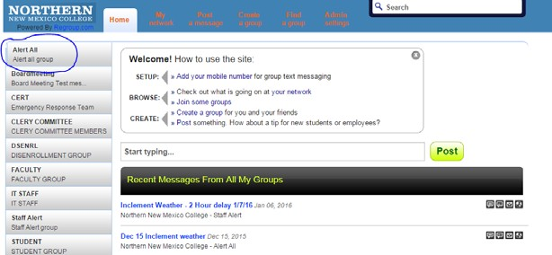
- You will be presented with this screen >>

- Select the Group you want to send the message to. In Emergencies, you want to send the message to the ‘Alert All’ Group as indicated.

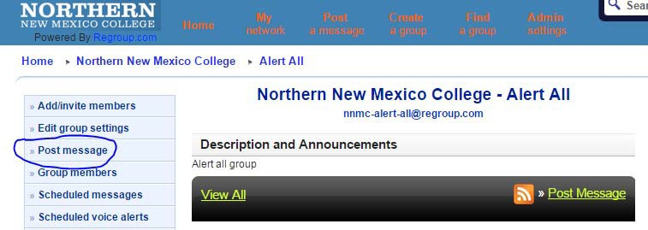
- Once selected you will be presented the this screen >>

- Select ‘Post message’

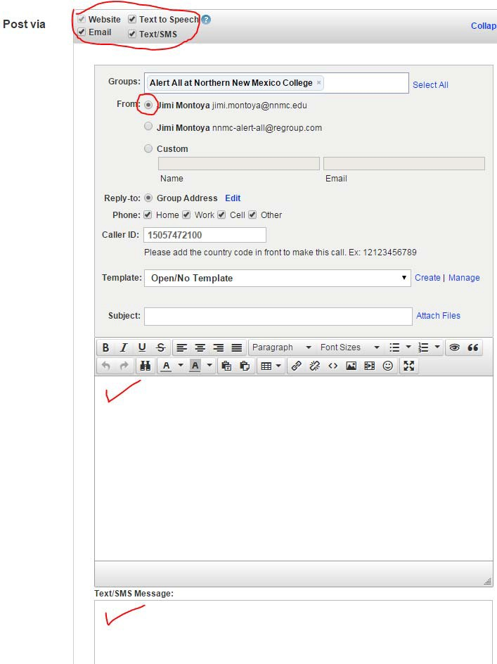
- Complete all areas circled in RED. You may also select a pre‐established message from the Template section of this page.

Template >>

- Insert your message here >>


- Hit Post. Your message is sent and will be received within 15 seconds.

Make sure your record all activity for inclusion into the ‘NNMC Campus Emergency Response Incident Report’. Once the CERT members have convened, you may be instructed to send out additional notifications or updates.

Make notes of how you may improve this process and/or procedure.

APPENDIX B

BOMB THREAT CHECKLIST

Keep a copy of this page under your phone.

- EXACT WORDING OF THE THREAT:

- ASK THE CALLER 6. ESTIMATE OF CALLER’S VOICE

 | a. What can you tell me? | Sex Age
 | b. When is the bomb going to explode?
 | c. Where is it right now? | Calm Nasal
 | d. What kind of bomb is it? | Angry Stutter
 | e. What will cause it to explode? | Excited Lisp
 | - Did you place the bomb?  - Why? | Slow Raspy  Rapid Deep
 | h. What is your address? | Soft Ragged
 | i. What is your name? | Loud Clearing Throat  Laughter Deep Breathing
3. | REPORT THREAT IMMEDIATELY TO: | Crying Cracking Voice
 | Your supervisor; | Normal Disguised  Distinct Accent
 | Floor or Building Custodian; | Slurred Familiar
 | (In some cases) (505) 747‐2158. | If voice was familiar, who did it sound like?

- BASIC CALL INFORMATION 7. BACKGROUND NOISES:

Time of threat: Street noises Office machinery
Restaurant Voices
Date: Factory machinery Animal noises
PA System Clear

Your Name:
Music Static
Household noises Local

Position: Motor Long Distance
Other:
Phone Number where threat
was received:
8. REMARKS

- THREAT LANGUAGE

Well‐spoken Incoherent
Foul Taped
Irrational Message was read

APPENDIX C

Hazardous Material Safety Sheet

Insert Here

APPENDIX D
NNMC Accident/Injury Report

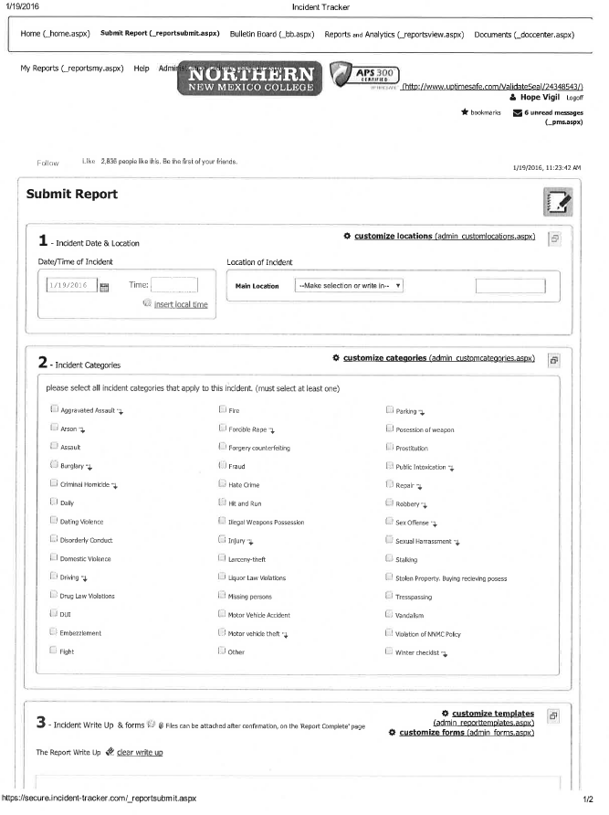
This report is a blank extract from the Campus Security Office.

APPENDIX E
INSERT: Accident Identification Card, Std Form 269

APPENDIX F
INSERT: Report of Vehicle Accident, Std. Form 270

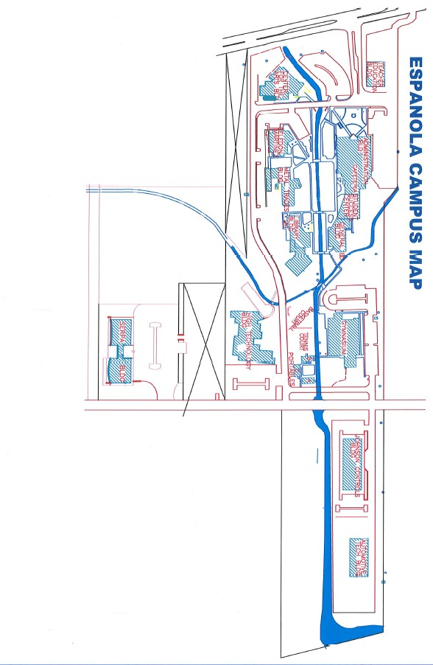
APPENDIX G
Campus Floor Maps

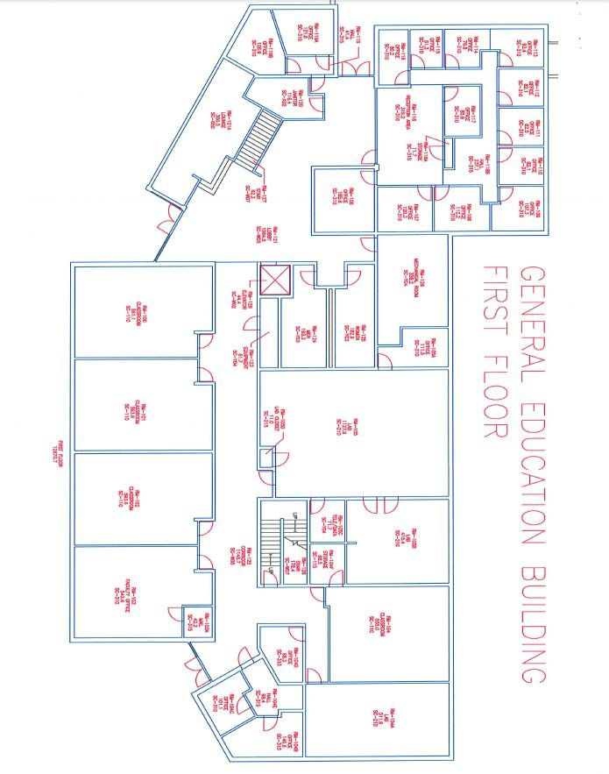

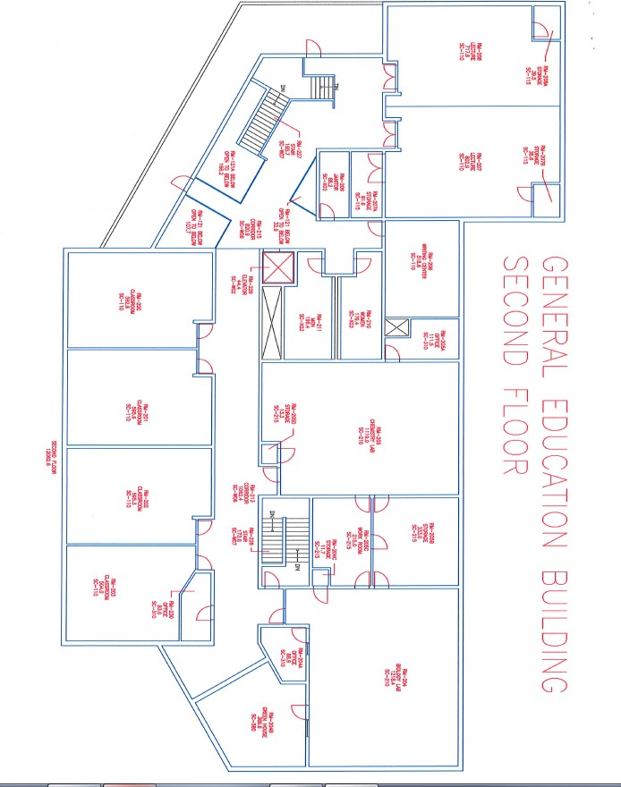

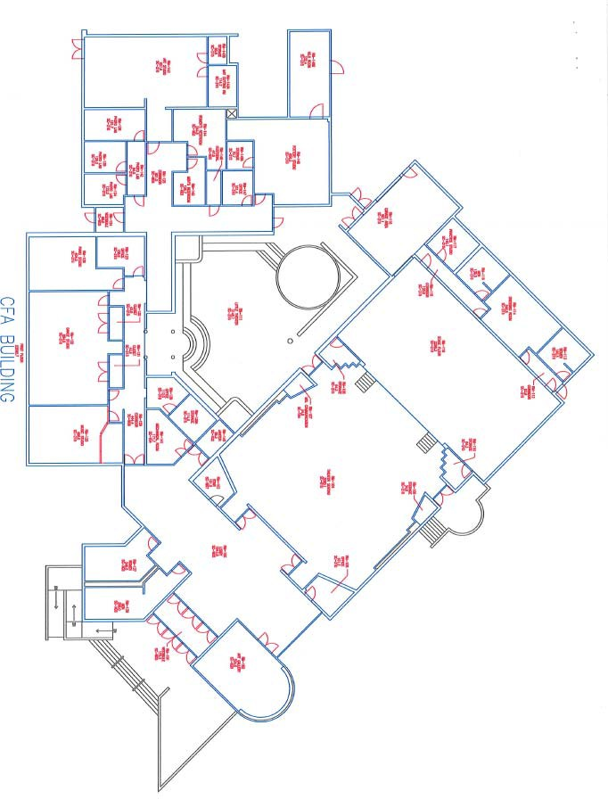

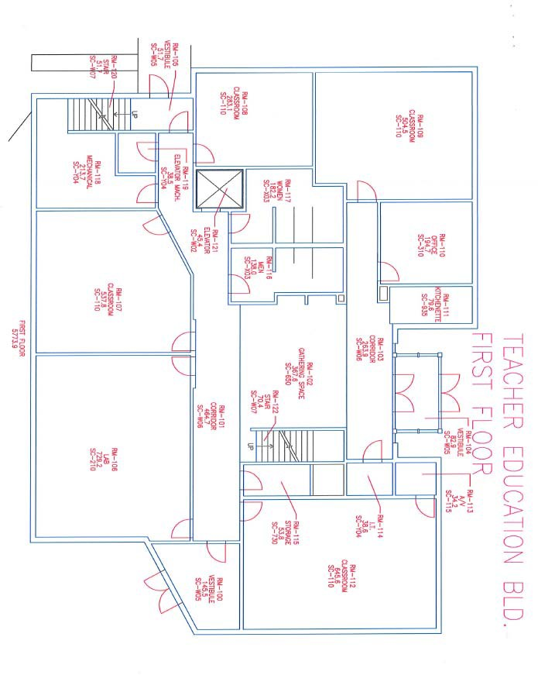

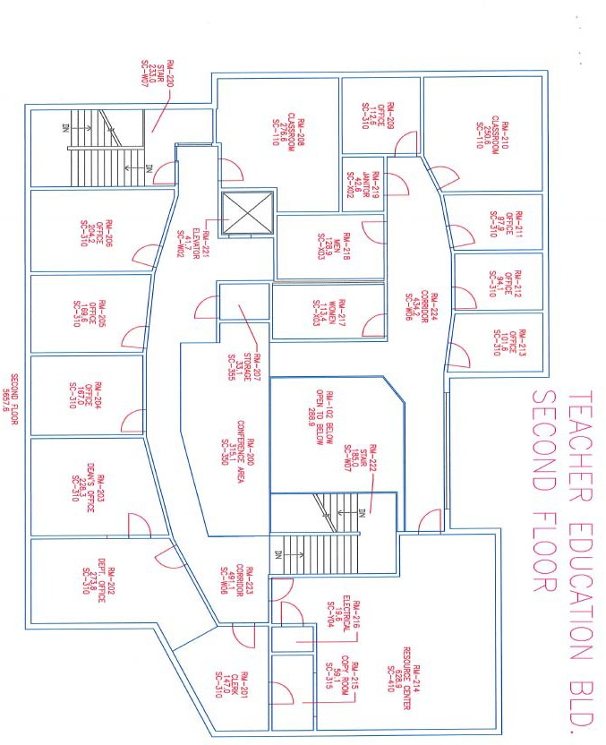

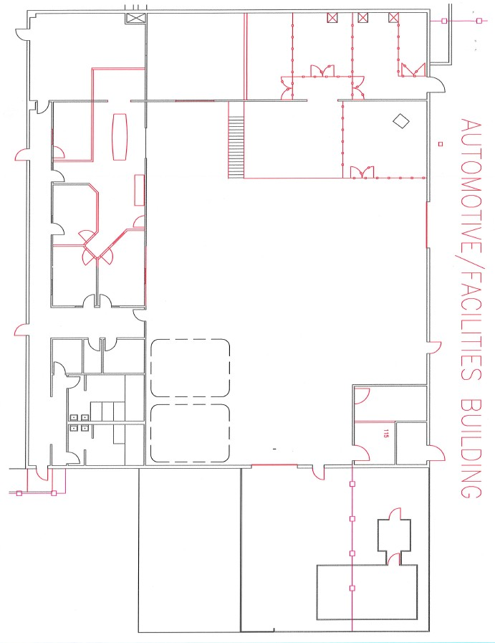

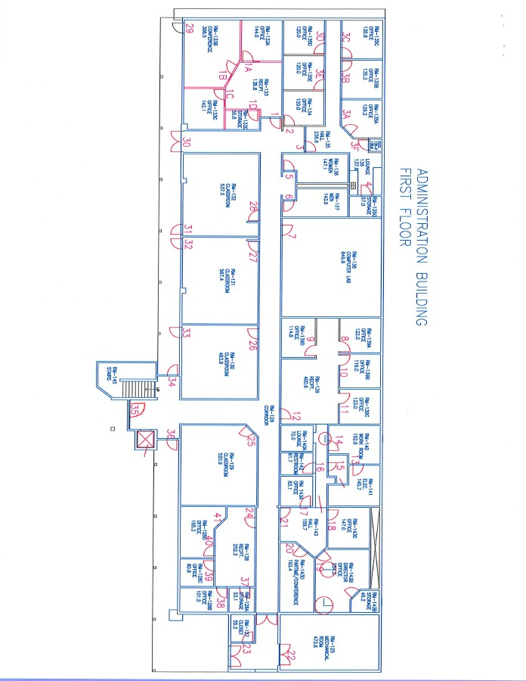

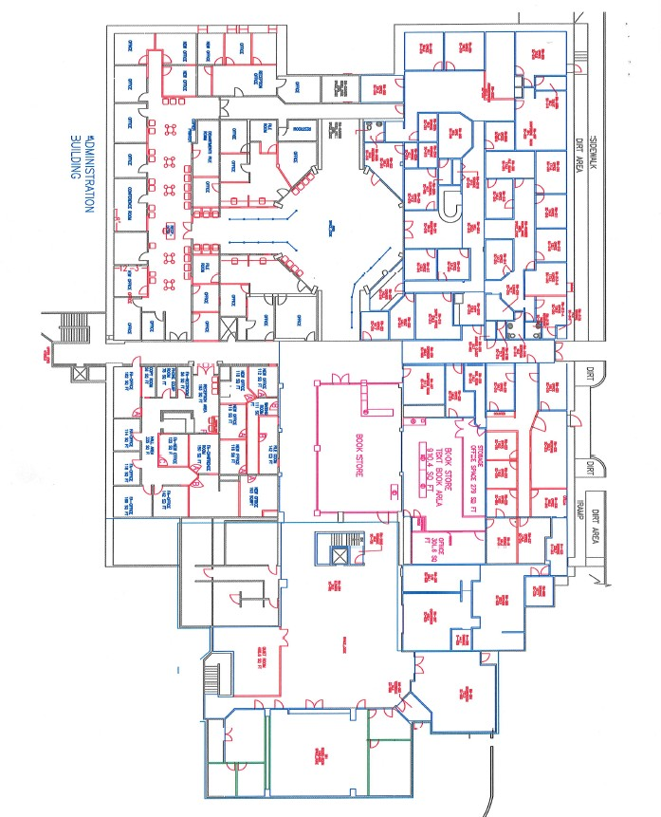

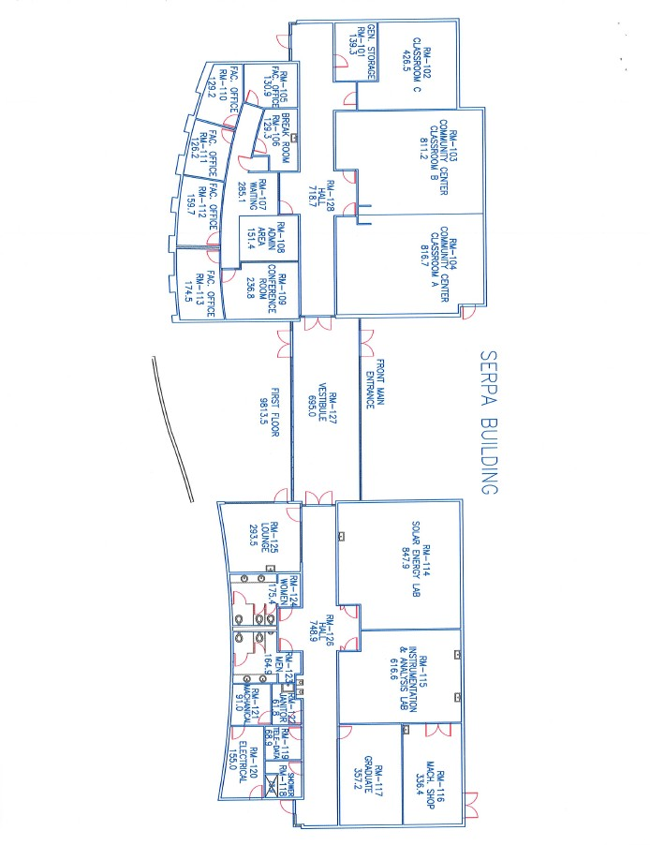

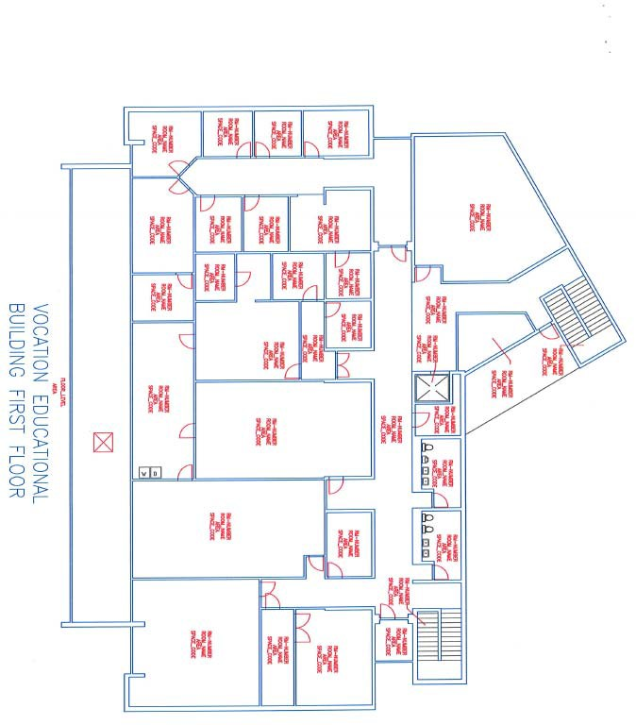

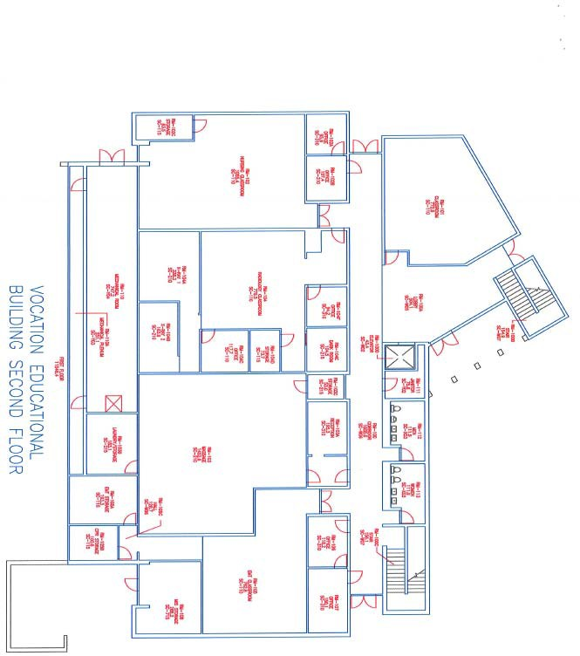

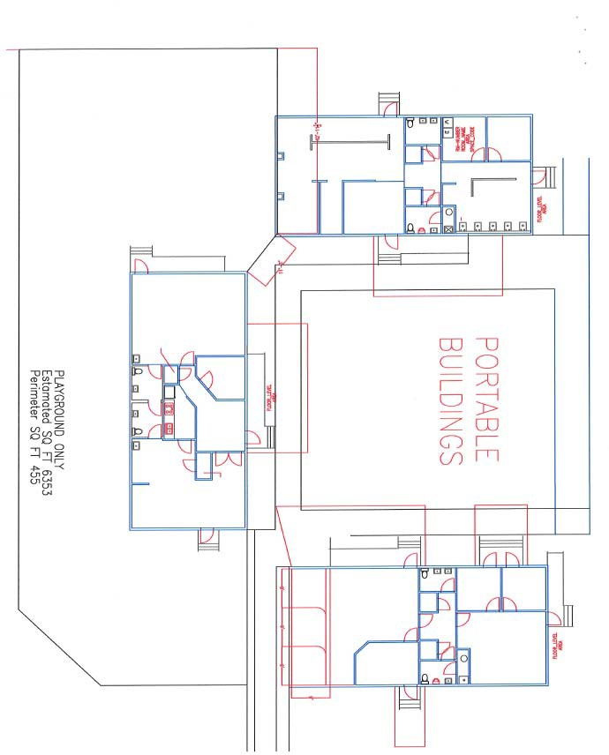

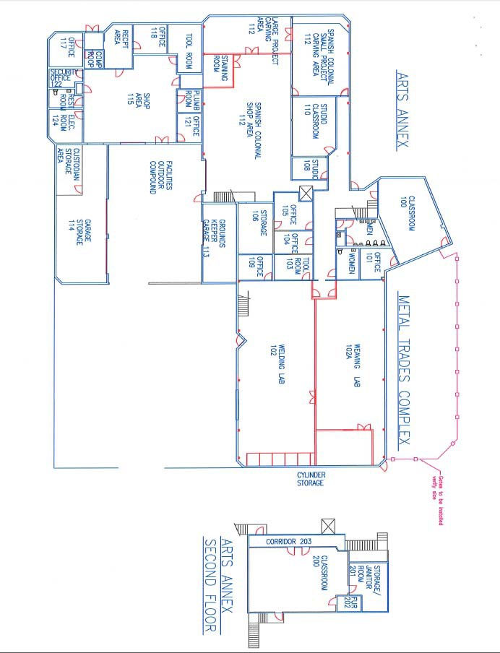

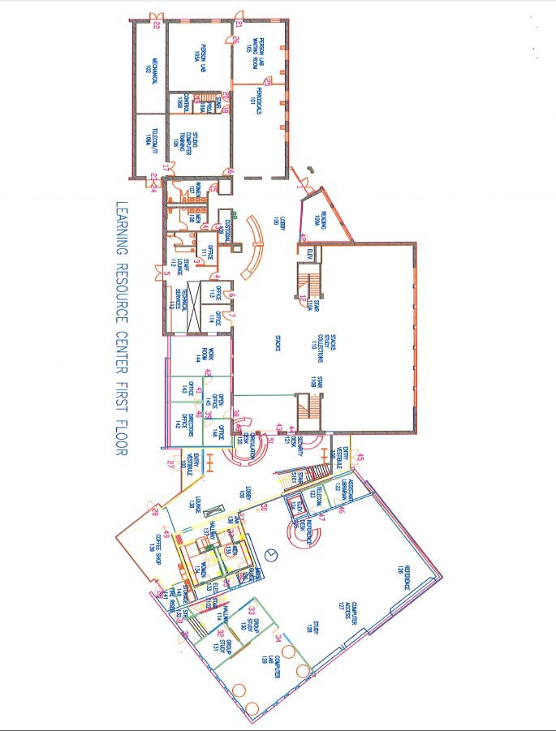

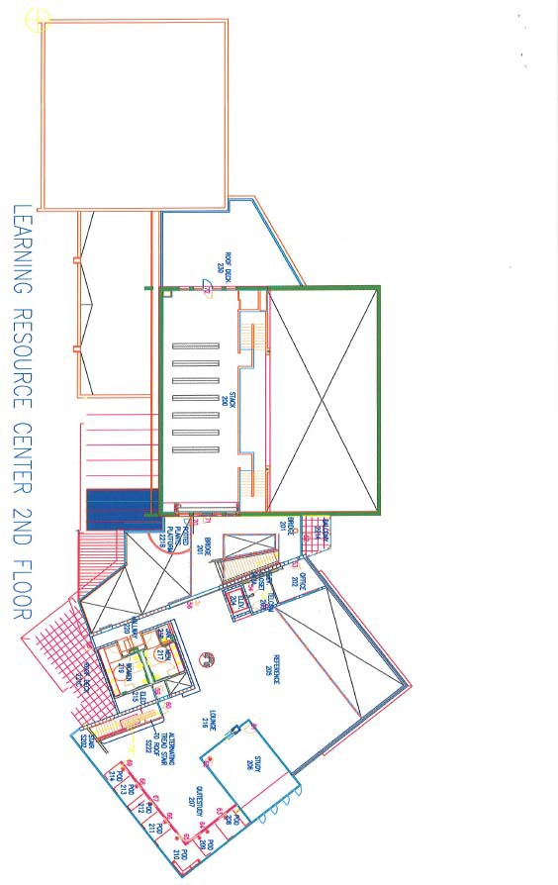

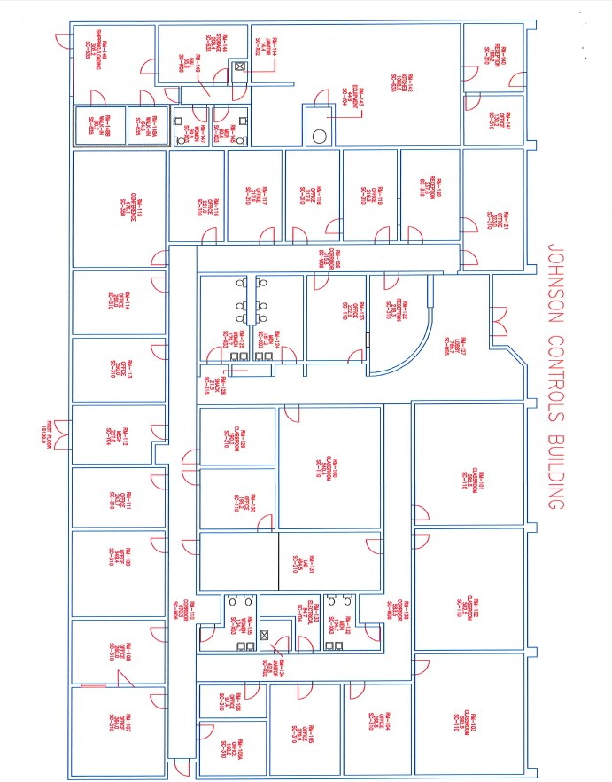

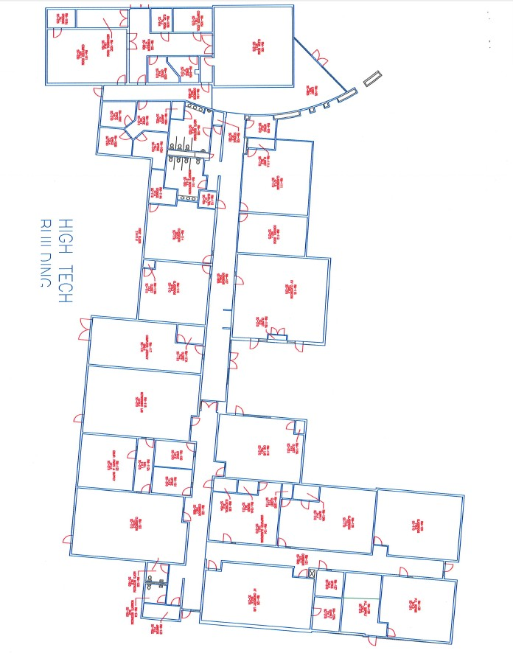

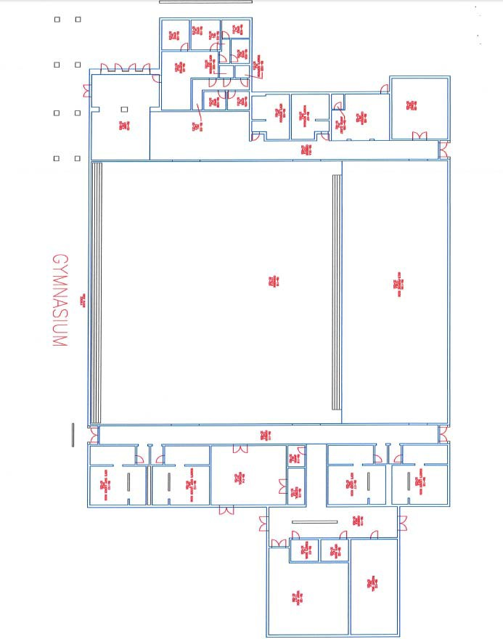

APPENDIX H
Robbery Procedures

Robbery Response Kit

Having the proper documents handy after a robbery has occurred will greatly ease the process of making sure that you get all of the information necessary to quickly apprehend and convict the robber. This robbery response kit can be amended to suit the needs of the campus community. It includes a description form that captures the characteristics of the robber and the robbery, and a form to help you get in contact with any witnesses and employees who were present when the robbery occurred.

Post Robbery Checklist

After a robbery occurs, the following steps should be followed to ensure that no one in the building has been injured, and to preserve evidence for law enforcement:
- Call law enforcement (usually 911 for local law enforcement) and the FBI. Be prepared to tell them that a robbery has just occurred, the address of the building, and any identification you can provide on the robber(s), vehicle(s) used and direction of escape.
- Contact the Campus Security office at (505)747‐2158.
- Ensure that no one needs medical attention or should be referred to your employee assistance program. If anyone is injured, call for medical assistance.
- If possible, post a notice at the main entrance to notify everyone we are temporarily closed.
- Station someone near the main entrance to wait for the police. Let no one into the building except law enforcement.
- Give each witness (employees or customers) a description form to help them recollect what they saw, or give each witness a piece of paper to make notes about what they observed.
- If customers insist on leaving, get their names and phone numbers to share with law enforcement, if needed.

- Protect any areas that the robber(s) touched visited to preserve any fingerprints or any footprints they might have left.

Robbery Description Form

Fill in the blanks immediately after a robbery and before you compare notes with anyone else. Describe or circle only those items you are sure of. Use the blank figure to draw in hard‐to‐describe details such as patterns of clothing and/or location of scars. Please provide additional copies of this form for each robber.

Date of Robbery: |  |  | Time:
Institution or Company Name:
Branch:
Address:
Phone:
Your Name:
Home Address:
Phone:
Position:
Signature:
Date: |  |  | Time:
SPEECH: | Loud Soft Lisp Slow High‐Pitched Refined Rapid Nasal Deep Stutter  Other: (describe):
ACCENT: | Local Eastern Southern Western Foreign  Other (describe):
WEAPON: | Semiautomatic Revolver Knife Rifle Pistol  Automatic Rifle Submachine Gun Shotgun Sawed‐Off Shotgun  COLOR: Black Shiny Other:
DESCRIBE WEAPON
ROBBERY DETAIL | Did robber use a note? Yes No  Did you retain note? Yes No
ROBBERY DETAIL | If you were unable to keep the note – what did it say?
ROBBERY DETAIL | If robber spoke – what did he or she say?
ROBBERY DETAIL | Did the robber have an accomplice you were aware of? Yes No

ROBBER’S ESCAPE | Don’t Know On Foot Car Other Vehicle  Type of Vehicle:
ESCAPE VEHICLE | Make:
ESCAPE VEHICLE | Model:
ESCAPE VEHICLE | Color:
ESCAPE VEHICLE | Year:
ESCAPE VEHICLE | License Number:
ESCAPE VEHICLE | Number of Other Passengers in Vehicle:
ESCAPE VEHICLE | Direction Taken:
ADDITIONAL NOTES OR DESCRIPTIONS

HEIGHT: | WEIGHT: RACE: |  | APPARENT AGE:
SEX: | Male Female |  |   Please use the blank figure to draw in any hard‐to‐describe details such as patterns of
COMPLEXION: | Sallow Light Ruddy | Freckle Dark
HAIR COLOR: | Blond Red Brown  Partially Gray Other: | Gray Black
FACIAL HAIR | Beard Unshaven | Moustache
HAIR STYLE: | Long Short  Bald Wig  Medium Curly | Medium Straight  Partially Bald
EYEBROWS: | Bushy  High Over Eyes | Thin  Low Over
EYES: | Large Wide Set  Close Pouches Together  Droopy | Small Deep Set
EYE COLOR: | Blue Gray  Brown Black | Hazel
NOSE: | Small Large  Short Thin | Long  Wide
TEETH: | Straight Crooked Buck  Discolore Some Missing
CHIN: | Long Square Prominen | Receding
EARS: | Small Prominen
MASK: | Yes No
HANDS: | Right‐handed Left‐handed
CLOTHING:  Circle items and describe: | Suit: |  | Gloves:
CLOTHING:  Circle items and describe: | Jacket: |  | Hat:
CLOTHING:  Circle items and describe: | Sweater: |  | Shoes:
CLOTHING:  Circle items and describe: | Slacks: |  | Overcoat:
CLOTHING:  Circle items and describe: | Skirt or Dress: |  | Raincoat:
CLOTHING:  Circle items and describe: | Tie: |  | Windbreaker:
CLOTHING:  Circle items and describe: | Belt Buckle:
Other Marks and Characteristics: Describe any other personal characteristics such as scars, tattoos, birthmarks, limp, twitch, deformities, amputations, or any jewelry such as a watch, ring, necklace, earring, etc., that the robber wore:

Action Items:

DOCUMENTATION – INSERT Individual Department Emergency Response Procedures EMERGENCY RESPONSE KITS – Determine if these need to be put together and distribute APPENDIX C: Need to produce a Hazardous Materials Safety Data Sheets (MSDS)
APPENDIX E: INSERT Report of Vehicle Accident, Std. Form 269 APPENDIX F: INSERT Report of Vehicle Accident, Std. Form 270

