Campus Guidelines for Responding to Disruptive or Threatening Student Behavior

QUICK REFERENCE
- Call 911 if the situation is life threatening
- Call Safety and Security at 505-747-2178 and your direct supervisor.

If you need to consult with someone about a student who is disruptive or seems to be showing signs of emotional distress, mental illness or difficulty in adjusting to college life, contact the following:

Student Conduct
  - Dr. Larry Guerrero, Associate Vice President for Student Success 505.747.2226

Counseling & Student Support Center
  - Adam Baca, MA, LPCC-Behavioral Health Counselor 505-927-5464
Adam.baca.@nnmc.edu
- Khiana Seaboy, BAIS-Title IX Coordinator 505-747-2147
Khiana.seaboy@nnmc.edu

Services for Students with Disabilities

Please tell students about these offices or call the office while the student is with you to make sure he or she gets an appointment.

IDENTIFYING AND REFERRING A STUDENT WHO MAY BE DISTRESSED

Some behaviors you may see:
- Dependency (e.g., the student who hangs around or makes excessive appointments)
- Marked changes in personal hygiene
- Unusual dress for the season (e.g. a down parka in 90 degree weather)
- Impaired speech and disconnected thoughts
- Repeated requests for special consideration (e.g., deadline extensions)
- Threats to others
- Expressed suicidal thoughts (e.g., referring to suicide as a current option)
- Excessive weight gain or loss
- Frequent or high levels of irritable, unruly, abrasive, or aggressive behavior
- Appears to be under the influence of alcohol or some other substance
- Unable to make decisions despite your repeated efforts to clarify or encourage
- Bizarre behavior that is obviously inappropriate for the situation (e.g., talking to something/someone that is not present)
- Students who appear overly nervous, tense or tearful

SOME GUIDELINES FOR INTERACTING WITH DISTRESSED STUDENTS
- Talk to the student in private.
- Express concern. Be as specific as possible in stating your observations and reasons for concern.
- Listen carefully to everything the student says.
- Repeat the essence of what the student has told you so your attempts to understand are communicated.
- Avoid criticizing or sounding judgmental (suspend judgment).
- Consider Counseling Services as a resource and discuss referral with the student.
- If the student resists referral and you remain uncomfortable with the situation, contact the Student Affairs Officer or a Counselor to discuss your concern.

DEVELOP A STRATEGY FOR ENCOUNTERING A DIFFICULT STUDENT

Precautions to take include:
- Always know that Safety and Security are only a phone call away 428-1224. Call them immediately if you feel threatened by a student.
- Create a code word or phrase, distribute it among the staff in your area, and be ready to respond. That word would serve as a signal to others to call for help outside your office. For example, you could establish the name “Mr. Pitt” as a code word. If you are in the front office of an academic school and you find yourself confronted by a threatening student, you can call into another room or on an intercom and say “my next appointment is with Mr. Pitt – can you call and let him know I’m running late?” This will act as a sign to whoever is within hearing distance to call security. It does not mean to come into the office or to double check the situation. It means CALL SECURITY IMMEDIATELY.
- Terminate any conversation immediately if your "sixth sense" tells you something is wrong.
- Avoid body language that appears challenging such as placing your hands on your hips, moving into the student’s territory, or using aggressive facial expressions (e.g. staring). If possible, suggest that you and the student sit rather than stand.
- Slow your rate of speech down and use a low pitch and volume to reduce the momentum of the situation.
- Ask to consult your supervisor, a department head, or the Student Affairs Officer to help satisfy the agitated person's need to feel heard.
- Listen carefully by really paying attention to what is said and take notes if possible. Let the student know you will help within your ability to do so and within reason.
- Ask questions to help regain control of the conversation and to understand the situation.
- Neither agree with distorted statements nor attempt to argue. Avoid defensiveness.
- Terminate the meeting if the student remains belligerent and tell him/her that you will not continue until he/she calms down.
- Never physically touch an outraged student or try to force them to leave.
- If a weapon becomes evident, leave. If that is not possible, calmly ask the person to leave any weapon in a neutral position as you continue talking calmly. (Notify Safety and Security as soon as you are able!) This is also an excellent example of when a code word or phrase would be useful.
- Never agree to go to an unmonitored location with a potentially violent person.

Filing a Student Incident Report
- Anyone who has observed these types of behaviors can file an incident report.
- The incident report plus additional tools are available on Jack under the Employee and Faculty tab. Click on Quick Links – Forms & Guidelines and then click on Student Behavior.
- Please make your supervisor aware of the incident.

Crisis Support & Resources

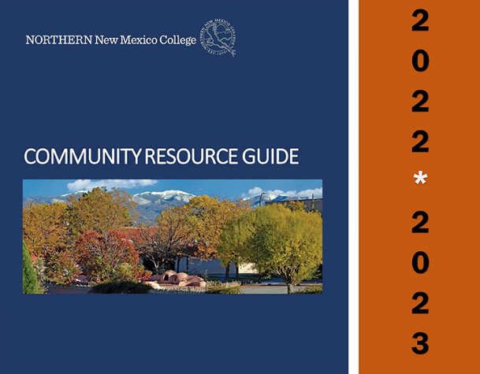

Assistance is available at the Counseling and Student Support Center during regular business hours to help with a range of difficulties from mental health challenges to food insecurities. Need to talk to someone outside of these hours or looking for a local resource to help meet your needs? Check out our Community Clinical, Behavioral, and Social Services Resource Guide. where you can find an extensive list of resources and services in the Rio Arriba and surrounding counties. This two-part tool includes a community resource directory and an emergency crisis helpline guide.
FOR EMERGENCIES, if you or someone you know is in danger of harming themselves or someone else, IMMEDIATELY call 911 or go to the nearest hospital emergency room.
For other supports to help you through your time of need, see the listing below of crisis helplines. For the full list of helplines and useful resources, visit our Community Clinical, Behavioral, and Social Services Resource Guide.
New Mexico Crisis and Access Line (Red para crisis y acceso de NM): 1 (855) NMCRISIS / 1 (855) 662-7474.
National Suicide Prevention Lifeline: 1 (800) 273-TALK / 1 (800) 273-8255.
Red Para la Prevención del Suicidio: 1 (800) 273-TALK / 1 (800) 274-8255.
New Mexico Peer to Peer Warmline (Red de Pares de NM): 1 (855) 4NM-7100 / 1 (855) 466-7100 or or text 1-855-466-7100
AGORA Crisis Center: 1-855-505-4505 or chat online at www.AgoraCares.org
For support regarding rape or sexual assault, contact Solace Crisis Treatment Center at 800-721-7273
For domestic violence, contact Esperanza Shelter 800-473-5220

