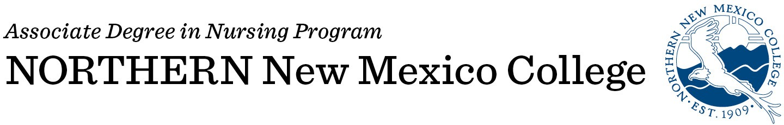

# Please type information:

**Date:**

|  |  |
| --- | --- |
| **Name:** | **Banner ID:** |
| **First Middle Last** |  |
| **DOB:** |  |
| **Previous or other names:** | |
| **Mailing Address:** | **Contact Numbers:** |
| **Address** | **Home** |
| **City State Zip Code** | **Cell** |
| **Personal Email:** | **Work** |
| **Northern New Mexico College Email:** |  |

**\*Please note you will need a NNMC email address in order to receive emails and correspondence**

# Name and telephone number of emergency contact person:

|  |
| --- |
| **Name:** |
| **Telephone number:** |

* I am aware that I must have achieved “regular” Admission to NNMC to be considered for the Nursing Program. I understand that filing this form does not guarantee acceptance in the Nursing Program. I am aware of the deadline dates on this packet and that this form is only valid for fall 2022 entry.
* Do you speak English as a second language? (i.e. is a language other than English your first language?)

# CERTIFICATION

I hereby certify that all statements on the application and essay are correct to the best of my knowledge. I understand that falsifications or omissions of information may result in disqualification or dismissal of this application to the Northern New Mexico College Associate Degree Nursing Program**.**

Application materials submitted as part of the application process become the property of the NNMC ADN Program and will not be returned. Please keep a copy of the entire application packet for your records.

|  |  |
| --- | --- |
| Signature: | Date: |

**Please send completed application packet to Ms. Denise Martinez Arevalo at denise.arevalo@nnmc.edu**

